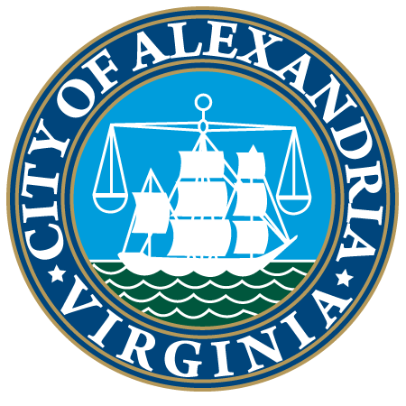

Joyce Hylton Receives Alexandria’s Ellen Pickering Environmental Excellence Award

(May 12, 2021 – ALEXANDRIA, VA) – The City of Alexandria Environmental Policy Commission (EPC) and Alexandria Renew Enterprises (AlexRenew) presented the 2021 Ellen Pickering Environmental Excellence Award to Joyce Hylton, a Master Gardener volunteer in the Arlington/Alexandria unit of the Virginia Cooperative Extension (VCE) Master Gardener program. The award was presented during last night’s City Council Legislative Meeting.
Hylton was selected for this award because of her significant service as a Master Gardener through VCE, an outreach program of Virginia Tech, Virginia State University, and the US Department of Agriculture. As a Master Gardener volunteer for the past 21 years, Hylton has contributed nearly 7,900 hours of volunteer service, supporting Alexandria residents in their gardening and landscaping needs, while encouraging and promoting environmentally sound horticulture practices.
“For over 20 years, Alexandrians have benefitted from Joyce Hylton’s knowledge, expertise, and generosity,” said Alexandria Mayor Justin Wilson. “She has led and trained over 240 volunteers, making a positive impact on so many people through various civic programs in Alexandria, while instilling a sense of responsibility to our natural environment.”
“Joyce Hylton's volunteer work makes her an outstanding recipient for the Ellen Pickering Environmental Excellence Award,” said AlexRenew CEO Karen Pallansch. “Her service and dedication to educating the citizens of Alexandria on sustainable landscape management to benefit our environment has established her as a role model for volunteers in our community.”
Through her extensive volunteer service, Hylton has served as an educator for Alexandria residents, providing 4-5 public programs per year on sustainable landscape management in various Alexandria community venues, including libraries and community centers – both in person and virtually. She is an active supporter of the VCE Master Gardener volunteer training program, at one time serving as the training coordinator while working to meet state standards for environmental best practices for Master Gardener educators.
Beyond her educator and trainer roles, Hylton is most often found behind the Master Gardener Help Desk supporting Alexandrians who call, email, or walk in to answer questions on a variety of subjects, including everything from tree care, soil testing, and plant selection to vegetable gardening and composting. Perhaps, the most important way she has served all Alexandrians is by being a fierce advocate for the presence and value of VCE, an organization that provides research-based scientific knowledge and services to our residents.
Joyce Hylton has passed along the values of environmental responsibility in her work for over two decades. Her service to the community, both as a mentor to over 240 Master Gardener volunteers and a teacher of sustainable landscaping best practices to so many Alexandrians, personify the Restore the Earth theme of Earth Day 2021.
The Ellen Pickering Environmental Excellence Award recognizes members of the Alexandria community who demonstrate a commitment to protecting the environment and preserving local natural resources. The award honors the late Ellen Pickering and her lifelong dedication to City preservation and conservation.
###
Led by a five-member citizen board, Alexandria Renew Enterprises (AlexRenew) is a special purpose authority that has been serving the City of Alexandria and parts of Fairfax County for the last 60 years. AlexRenew treats an average of 35 million gallons of wastewater per day, from more than 300,000 people, at its water resource recovery facility, located in Alexandria's southwest quadrant.

